This is to certify that

Mr: Phan Van Tuyen
Mr: Duong Van Dinh
Mr: Tran Trung Hieu
Mr: Pham Xuan Nam

In the process of design and development:

eProject: Doctors WebForum

Submitted by:

Faculty: Do Quoc Binh

Date of Issue: ………………

Authorized Signature:……………….

- Problem Definition

- Discribe the problem.

After reading the project specifications, the developer states the scope of the project very briefly. This is referred to as the problem definition. Queries related to the system can be one or more of the follwing:
- How will the user register to the Doctor Web Forum ?
- How to user can post a query and the other can reply?
- How to count the number of users registered and the number of users logged in are to be displayed at the top corner of the page?
- How to have a pop up window to be displayed where ever necessary like if a user registers or if the user enters a wrong password, etc.
- How to a user registers for the website, the details of users registered should counted.
- How to have option for the registered users, where his account can be made viewable based on public or private, i.e., if the user do not want to share his contact details, then he can chose the profile to be private, else he can chose the profile public.
- How to the details include the contact, personal, professional, qualification, experience, and as well the achievement details.
- How will the user use the advance search option ?
- What kind of login for Administrtor and User ?
- How to users only be able to can update his / her a/c., access the details, i.e., can only retrieve the details of the other doctors or users, post a query or a request, reply to a query or suggest.
- How will an Admin manage the forum and the users ?

- The main users
- Administrator
- Logged in use
- Guest
- The main function of application
      - Administrator functions:
  - Login or logout to the forum.
  - Can change the password and profiles after logging into the forum.
  - Create Forum Category.
  - Delete Forum Category.
  - Edit Forum Category.
  - Create Forum Topic.
  - Delete Forum Topic.
  - Delete Forum Post.
  - Edit Forum Topic.
  - Edit Forum Post.
  - Read forum topics, posts…
  - Submit thank for topics, posts…
  - Rating for topics, posts…
  - Change profile and include change password.
  - View profile of users other
  - Search
  - Delete users.
      - Logged in use:
- Login, logout to the forum.
- Create forum topics, posts, write message...
- Read Forum Topics, Posts...
- Submit thank for topics, posts…
- Rating for topics, posts…
- Change profiles include change password.
- View profiles users other.
- Search
      - Guest

- Read forum topics, posts…
- Registration.
- Search.

- Customer Requirement Specification (CRS)
Client:
  - Business/ Project Objective:
Our client is a doctor who is one of the famous Cardiac specialists in the country.
As he is one of the famous specialists in the country, he generally used to visit some
places for operating some patients with some critical cardiac conditions. Also he used
to get invitations from various colleges in the country for attending and giving the
seminars, also he runs a college, which is one of the famous Medical colleges in the
country.
Actually he wants an online application such as a discussion forum for the doctors in
the world, so that if any one is having any queries (for the junior doctors, etc.) or to
discuss some new cases in different fields. He wants this application to be developed
as this can bridge the gap between the various doctors available in the world and can
know each other through this portal. Also in case of any emergencies or for some
special cases one can go through the application and search for the various doctors
based on the specialization and the location which ever is suitable so that so many
people s lives can be saved.

  - Inputs provided by the Client:
    - Input for the application: Login in forum:
- Username
- Password
    - Outputs from the application.
    - Process Involved in the application.
- Generate sub-forums, topics.. on each forum.

III. Hardware Requirements:

- A minimum computer system will help you access all the tools in the courses is a Pentium IV 2.8GHz or better.

- 512 Megabytes of RAM or better.

- Hard disk requirement: Minimum 4GB

- Windows xp/vista/win7.

IV. Software Requirements:

- .NET Framework 2.0.
- Microsoft Visual Studio 2005.
- IIS 4.0 or higher.
- Mozilla FireFox
- Microsoft SQL server 2005

V. Scope of the Work (in brief):
Depending on the decision taken by the manager, the application needs to be developed with the following requirements.
  - Required to account to log into the system.
  - A GUI containing text boxes, buttons, drop – down list boxes, and labels, which will provide a user – friendly interface to the user to work with the application.
  - With Administrator can add new user. All object other can himself as change password.
        - with each object interface will work and function, respectively.

- Architecture & Design of the Project
The application will be made of a Web-based distributed three-tier architecture to support multiple user transactions at the same time.

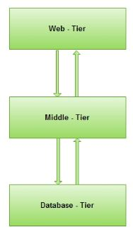
C# (Code-behind, App_Code - BLL ) files containing business logic
Web-Based Distributed 3-Tier Architechture of the Project
C# (App_Code – DAL)
Data Access Layer
User Interface with HTML and ASPX pages

Entitys

Form No.3/eProjects/Design/Ver1.0/1 of 1

D. Flow Chart
      - Flow Chart Login Admin
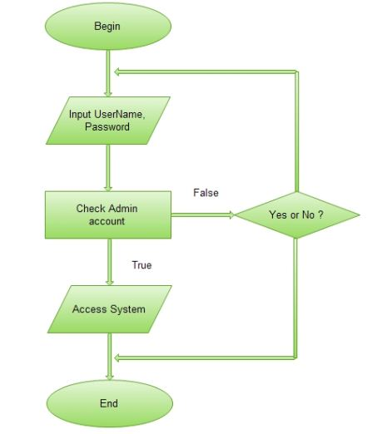

      - Flow Chart Login User

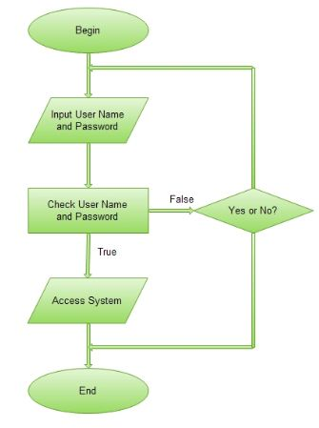

      - Flow Chart Register

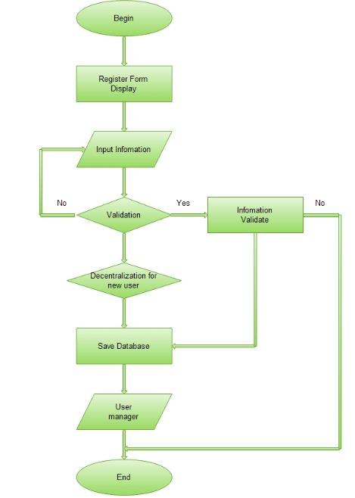

      - Flow Chart Search
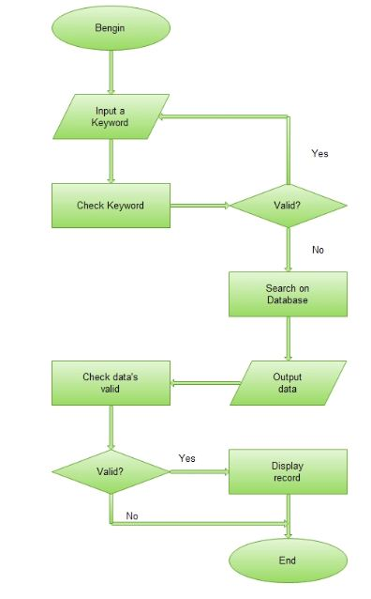

      - Flow Chart Delete
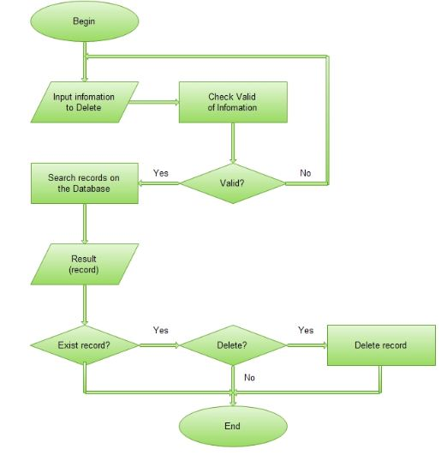

      - Flow Chart Post
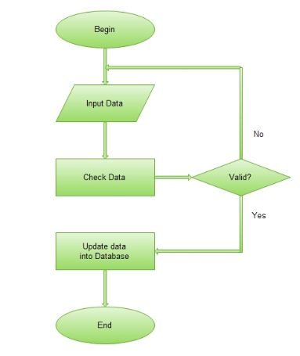

E. Entity Relationship (ER) Diagram
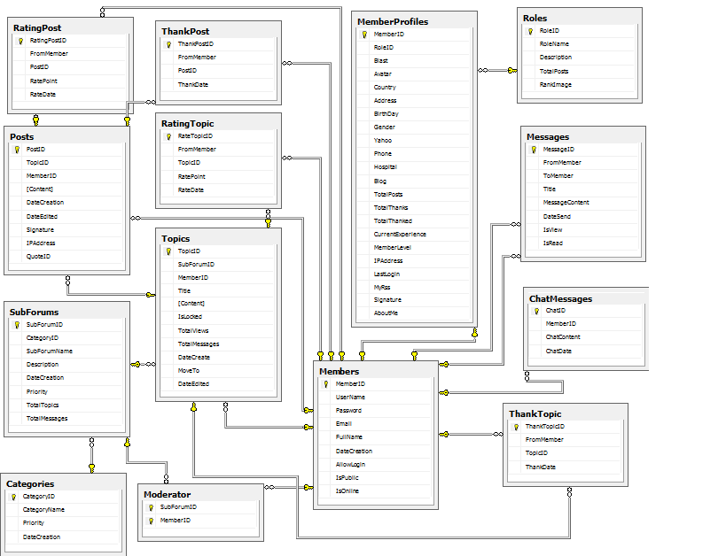

E – R Diagram

      - Database Design/Structure

Table : Members
Field Name | Data Type | Null | Key | Description
MemberID | Int | No | PK | Stores the ID of Member
UserName | Nvarchar(30) | Yes |  | Stores the of User Member
Password | Nvarchar(50) | Yes |  | Stores the password of Member
Email | Nvarchar(100) | Yes |  | Stores the email of Member
FullName | Nvarchar(50) | Yes |  | Stores the fullname of Member
DateCreation | DateTime | Yes |  | Stores the created date of Member’s account
AllowLogin | Bit | Yes |  | Check if Member’s account is lock or not
IsPublic | Bit | Yes |  | Check if Member is public or not
IsOnline | Bit | Yes |  | Check if Member is login or not

Table: ThankTopic
Field Name | Data Type | Null | Key | Description
ThankTopicID | Int | No | PK | Stores the ID of ThankTopic
FromMember | Int | No | FK | Stores the ID of Member
TopicID | Int | No | FK | Stores the ID of Topic
ThankDate | Datetime | Yes |  | Stores the date of ThankTopic

Table : MemberProfiles
Field Name |  | Data Type |  | Null | Key | Description
MemberID |  | Int |  | No | PK,FK | Stores the ID of Member
RoleID |  | Int |  | No | FK | Stores the RoleID of Roles
Blast |  | Nvarchar(100) |  | Yes |  | Stores the blast of Member
Avatar |  | Nvarchar(150) |  | Yes |  | Stores the avatar of Member
Country |  | Nvarchar(50) |  | Yes |  | Stores the country of Member
Address |  | Nvarchar(255) |  | Yes |  | Stores the address of Member
BirthDay |  | Datetime |  | Yes |  | Stores the birthday of Member
Gender |  | Bit |  | Yes |  | Stores the gender of Member
Yahoo |  | Nvarchar(100) |  | Yes |  | Stores the Yahoo account of Member
Phone |  | Nvarchar(15) |  | Yes |  | Stores the phone of Member
Hospital |  | Nvarchar(100) |  | Yes |  | Stores the hospital where Member works
Blog |  | Nvarchar(100) |  | Yes |  | Stores the blog account of Member
TotalPosts |  | Int |  | Yes |  | Stores the quantity post of Member
TotalThanks |  | Int |  | Yes |  | Stores the quantity thanks of Member
TotalThanked |  | Int |  | Yes |  | Stores the quantity thanked of Member
CurrentExperience | Float |  | Yes |  |  | Stores the Current Experience of Member
MemberLevel | Int |  | Yes |  |  | Stores the Level of Member
IPAddress | Nvarchar(50) |  | Yes |  |  | Stores the ip address of Member
LastLogin | DateTime |  | Yes |  |  | Stores the date lastlogin of Member
MyRss | Nvarchar(300) |  | Yes |  |  | Stores the date Rss of Member
Signature | Nvarchar(1000) |  | Yes |  |  | Stores the signature of Member
AboutMe | Ntext |  | Yes |  |  | Stores the about of Member

Table: Categories
Field Name | Data Type | Null | Key | Description
CategoriesID | Int | No | PK | Stores the id of Category
CategoryName | Nvarchar(50) | Yes |  | Stores the name of Category
Priority | Int | Yes |  | Stores the date priority of Category
DateCreation | Datetime | Yes |  | Stores the date create of Category

Table: ChatMessages
Field Name | Data Type | Null | Key | Description
ChatID | Int | No | PK | Stores the ID of ChatMessages
MemberID | Int | No | FK | Stores the ID of Member
ChatContent | Ntext | Yes |  | Stores chatcontent of ChatMessages
ChatDate | Datetime | Yes |  | Stores chat date of ChatMessages

Table: Messages
Field Name | Data Type | Null | Key | Description
MessageID | Int | No | PK | Stores the ID of Message
FromMember | Int | No | FK | Stores the ID of
ToMember | Int | No | FK | Stores the ID of
Title | Nvarchar(100) | Yes |  | Stores the title of Message
MessageContent | Ntext | Yes |  | Stores the message content of Message
Datesend | Datetime | Yes |  | Stores the date of sending Message
IsView | Bit | Yes |  | Stores the enable or disable view
IsRead | Bit | Yes |  | Stores the enable or disable read.

Table: Moderator
Field Name | Data Type | Null | Key | Description
SubForumID | Int | No | PK,FK | Stores the ID of Moderator
MemberID | Int | No | FK | Stores the ID of Member

Table: Posts
Field Name | Data Type | Null | Key | Description
PostID | Int | No | PK | Stores the ID of Post
TopicID | Int | No | FK | Stores the ID of Topic
MemberID | Int | No | FK | Stores the ID of Member
Content | Ntext | Yes |  | Stores the content of Post
DateCreation | Datetime | Yes |  | Stores the date of Post
DateEdited | Datetime | Yes |  | Stores the date when Member edit Post
Signature | Bit | Yes |  | Stores the signature of Member
IPAddress | Nvarchar(50) | Yes |  | Stores the IPAddress of Member
QuoteID | Int | Yes |  | Stores the ID of PostID

Table: RatingPost
Field Name | Data Type | Null | Key | Description
RatingPostID | Int | No | PK | Stores the ID of RatingPost
FromMember | Int | No | FK | Stores the ID of Member Rating to Post
PostID | Int | No | FK | Stores the ID of Post
RatePoint | Int | Yes |  | Stores the rate point of Post
RateDate | Datetime | Yes |  | Stores the rate date

Table: RatingTopic
Field Name | Data Type | Null | Key | Description
RateTopicID | Int | No | PK | Stores the ID of RatingTopic
FromMember | Int | No | FK | Stores the ID of Member Rating to Topic
TopicID | Int | No | FK | Stores the ID of Topic
RatePoint | Int | Yes |  | Stores the point of Rating
RateDate | Datetime | Yes |  | Stores the rate date

Table: Roles
Field Name | Data Type | Null | Key | Description
RoleID | Int | No | PK | Stores the ID of Roles
RoleName | Nvarchar(20) | No |  | Stores the name of Roles
Description | Nvarchar(100) | Yes |  | Stores the
TotalPosts | Int | Yes |  | Stores Quantity of Post
RankImage | Nvarchar(100) | Yes |  | Stores rank image

Table: SubForums
Field Name | Data Type | Null | Key | Description
SubForumID | Int | No | PK | Stores the ID of SubForum
CategoryID | Int | No | FK | Stores the ID of Category
SubForumName | Nvarchar(100) | No |  | Stores the name of SubForum
Description | Nvarchar(500) | Yes |  | Stores the description of Subforum
DateCreation | Datetime | Yes |  | Stores the DateCreation of Subforum
Priority | Int | Yes |  | Stores the Priority of Subforum
TotalTopics | Int | Yes |  | Stores the TotalTopics of Subforum
TotalMessages | Int | Yes |  | Stores the TotalMessages of Subforum

Table: Topics
Field Name | Data Type | Null | Key | Description
TopicID | Int | No | PK | Stores the ID of Topic
SubForumID | Int | No | FK | Stores the ID of SubForum
MemberID | Int | No | FK | Stores the ID of Member
Title | Nvarchar(100) | Yes |  | Stores the title of Topic
Content | Ntext | Yes |  | Stores the content of Topic
IsLocked | Bit | Yes |  | Stores the status is locked
TotalViews | Int | Yes |  | Stores the quantity of View
TotalMessages | Int | Yes |  | Stores the quantity of Message
DateLastPost | Datetime | Yes |  | Stores the DateLastPost of Message
MoveTo | Int | Yes |  | Stores the MoveTo of Message
DateEdited | Datetime | Yes |  | Stores the Date if Member Edit Coment

Table: ThankPost
Field Name | Data Type | Null | Key | Description
ThankPostID | Int | No | PK | Stores the ID of ThankPost
FromMember | Int | No | FK | Stores the ID of Member
PostID | Int | No | FK | Stores the ID of Post
ThankDate | Datetime | Yes |  | Stores the date of ThankPost

Interface Design Document
1.Index page.
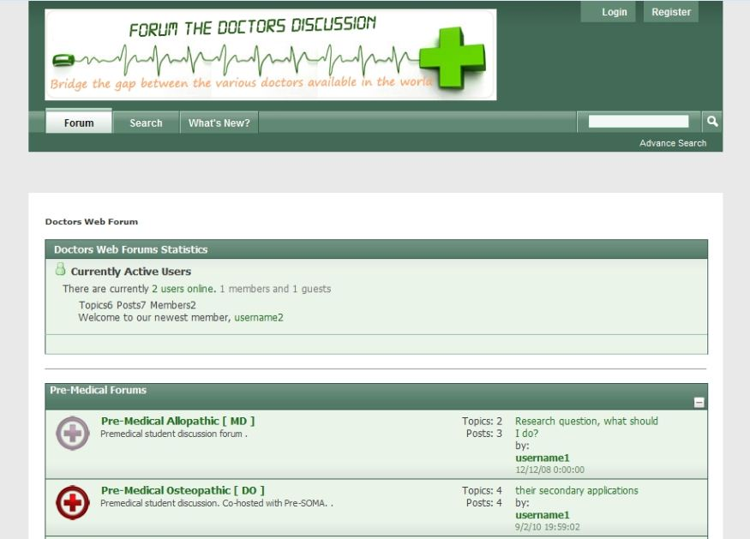
2. Topics List page.
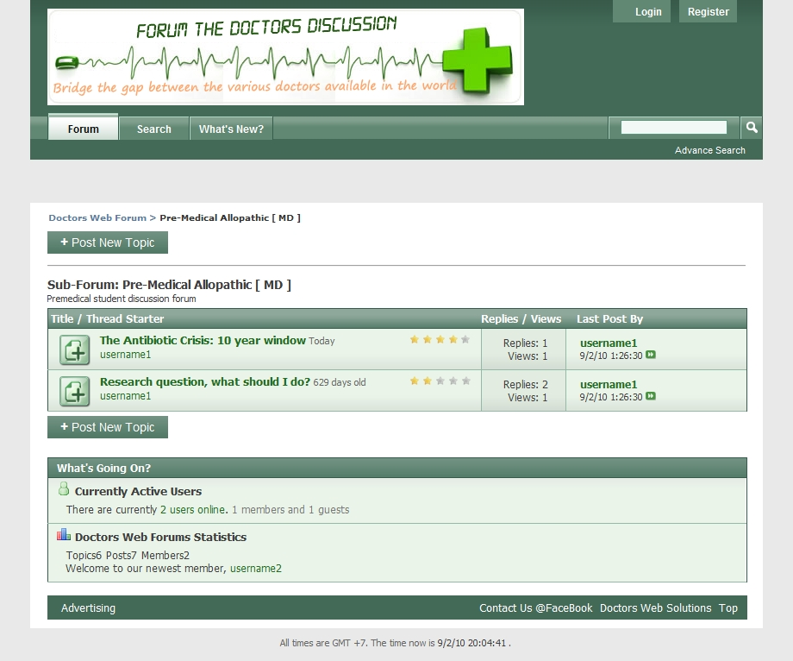

3. Topic Details page.
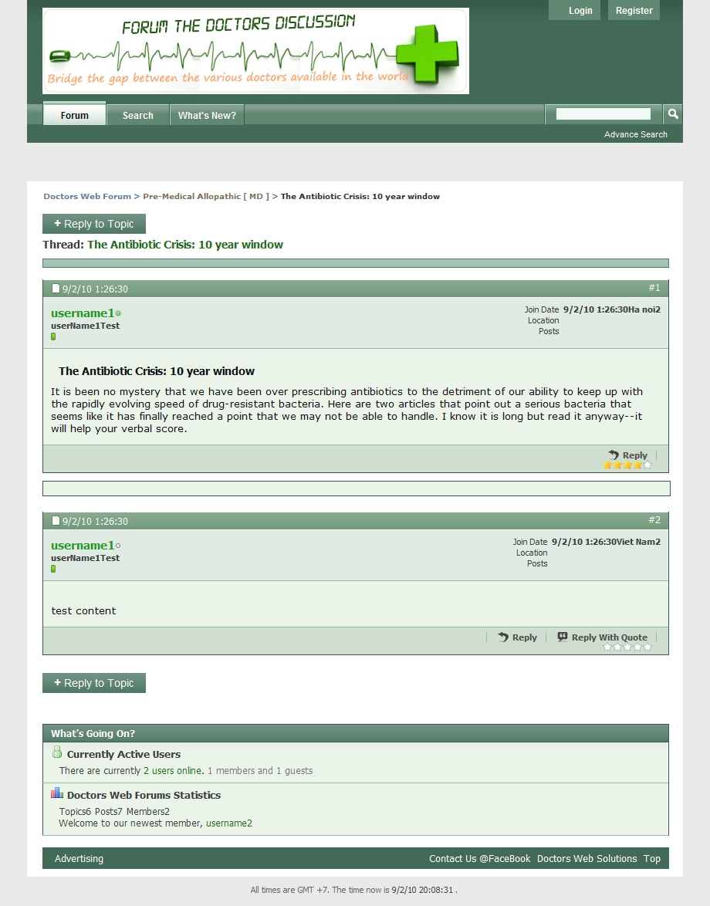

  - Edit Post page.
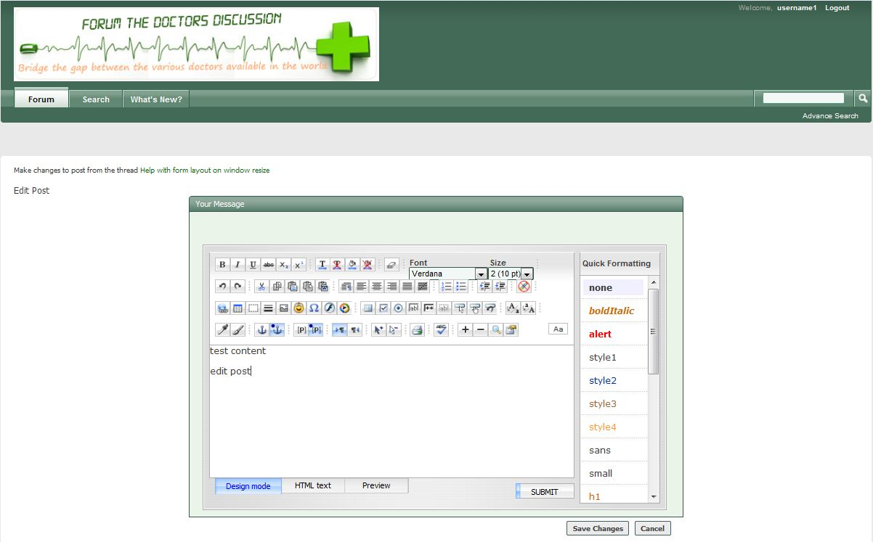

  - Edit Topic page.
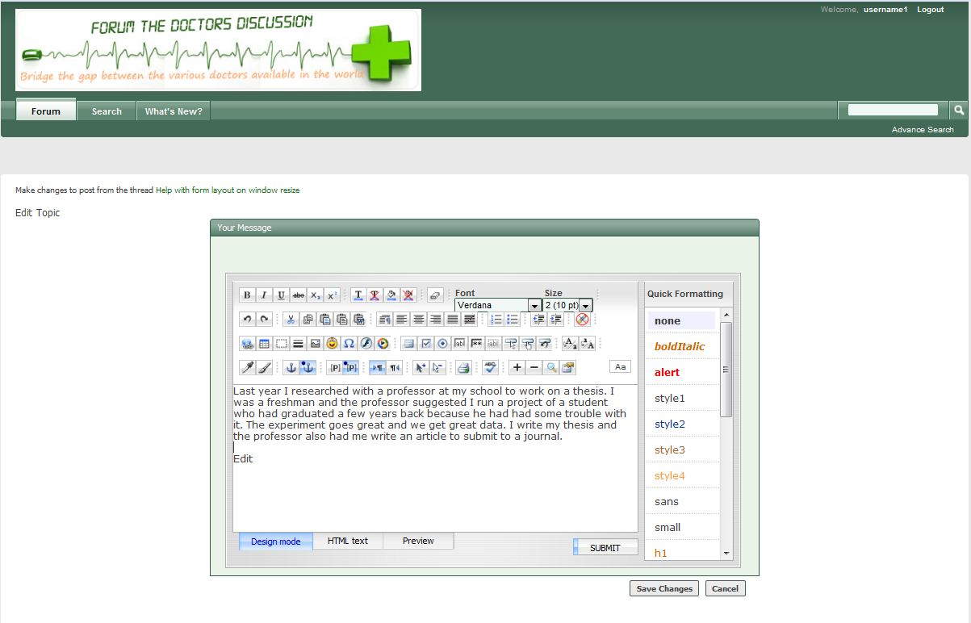
  - New Reply page
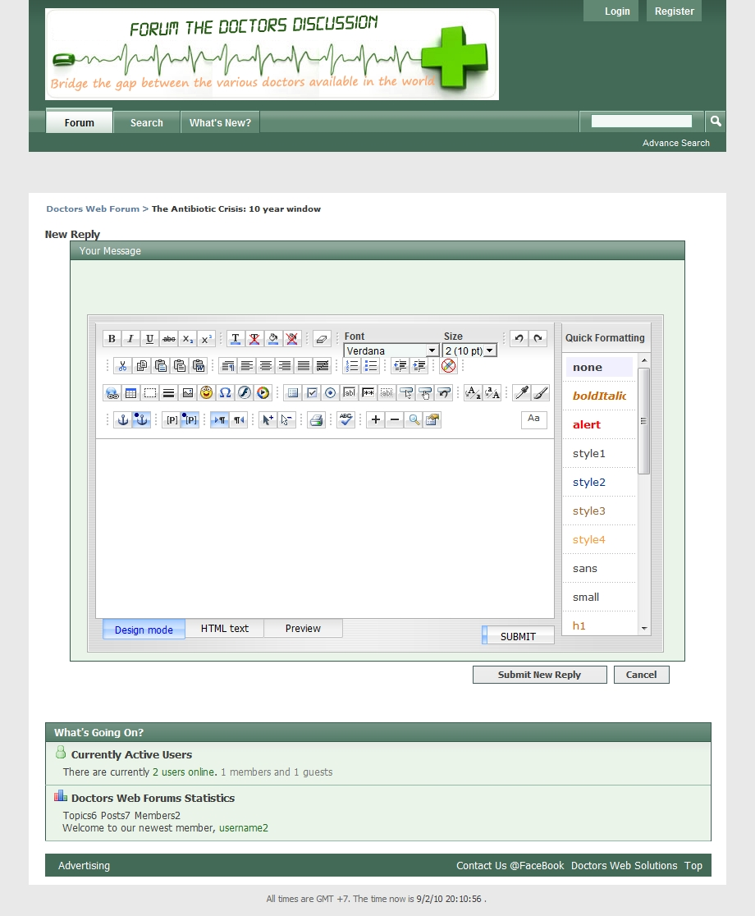

  - New Reply with quote page.
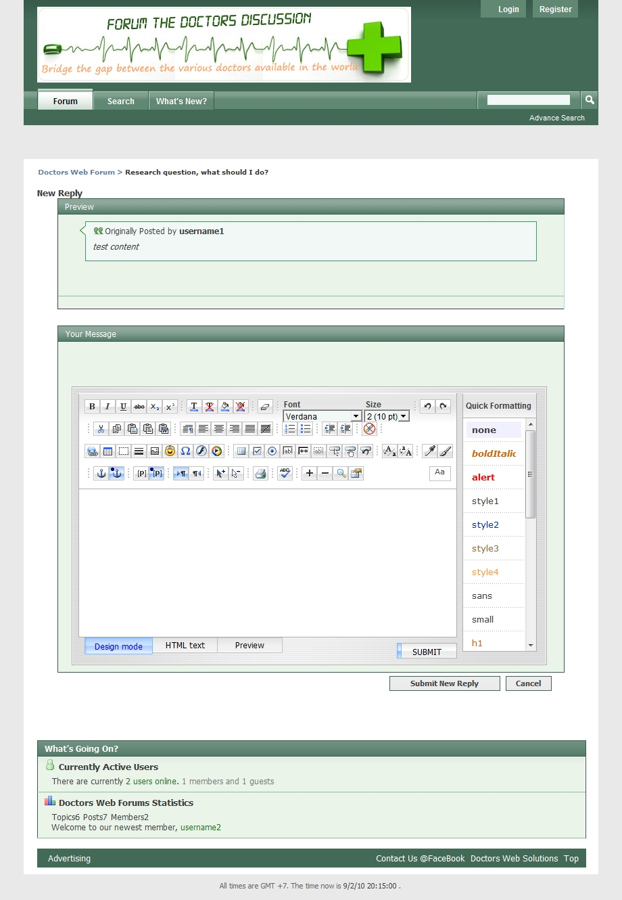

  - Register page.
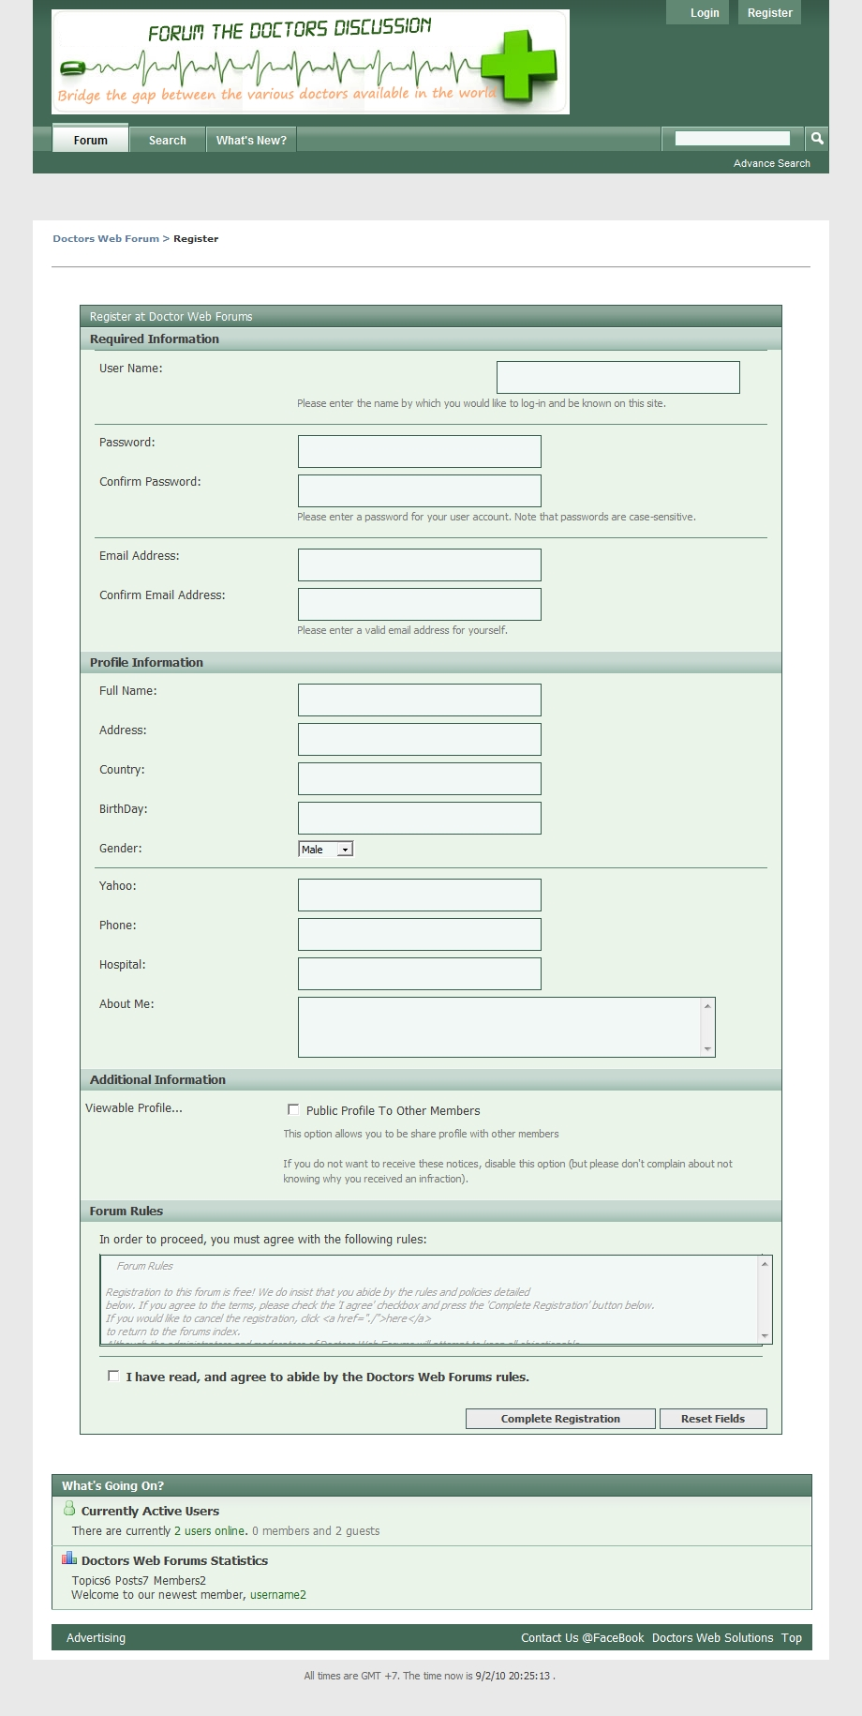
  - Search page.
